CS 499 Module One Assignment

Ericka Resendez

- Self-Introduction: Address all of the following questions to introduce yourself.
  - How long have you been in the Computer Science program?
I have been in the Computer Science program since the fall semester of 2022, totaling to less than four years.

  - What have you learned while in the program? List three of the most important concepts or skills you have learned.
Throughout the program, I have developed various skills and concepts, but have found the versatile programming languages, full stack development architecture, and algorithm optimization the most important. The different programming languages have allowed me to develop a foundation to be able to work on a variety of projects with different purposes. Full-stack development architecture taught me how to design cohesive systems that integrate frontend interfaces, backend logic, and databases into functional applications. Algorithm optimization has allowed me to formulate skills to evaluate and improve the efficiency of my code, including implementing advanced data structures and analyzing time complexity to enhance application performance and scalability.

  - Discuss the specific skills you aim to demonstrate through your enhancements to reach each of the course outcomes.
I aim to demonstrate technical and design skills that align with various course outcomes. For outcome two, I aim to exhibit professional-quality visual communication through the enhanced Animal Shelter Dashboard's intuitive React interface designed specifically for rescue teams. Using outcome three as a reference, and using the event tracking app I plan to demonstrate designing and evaluating computing solutions using advanced algorithmic principles. Additionally using outcome five, I plan on demonstrating a security mindset by implementing role-based access control, input validation, and secure data handling practices by using both of these projects.

  - How do the specific skills you will demonstrate align with your career plans related to your degree?
I am in the software engineering concentration which has allowed me to learn a great deal. I am currently interested in a future career as a full-stack software engineer. These skills like building scalable web apps, and optimizing performance through advanced algorithms prepares me for roles that will demand a breadth across the stack and depth in creating efficient, secure, and user-centered applications.

  - How does this contribute to the specialization you are targeting for your career?
This work contributes to my goal in a career as a full-stack software engineer by demonstrating a balanced competency in both frontend and backend development, along with specialized skills in performance optimization and system architecture.

- ePortfolio Set Up:
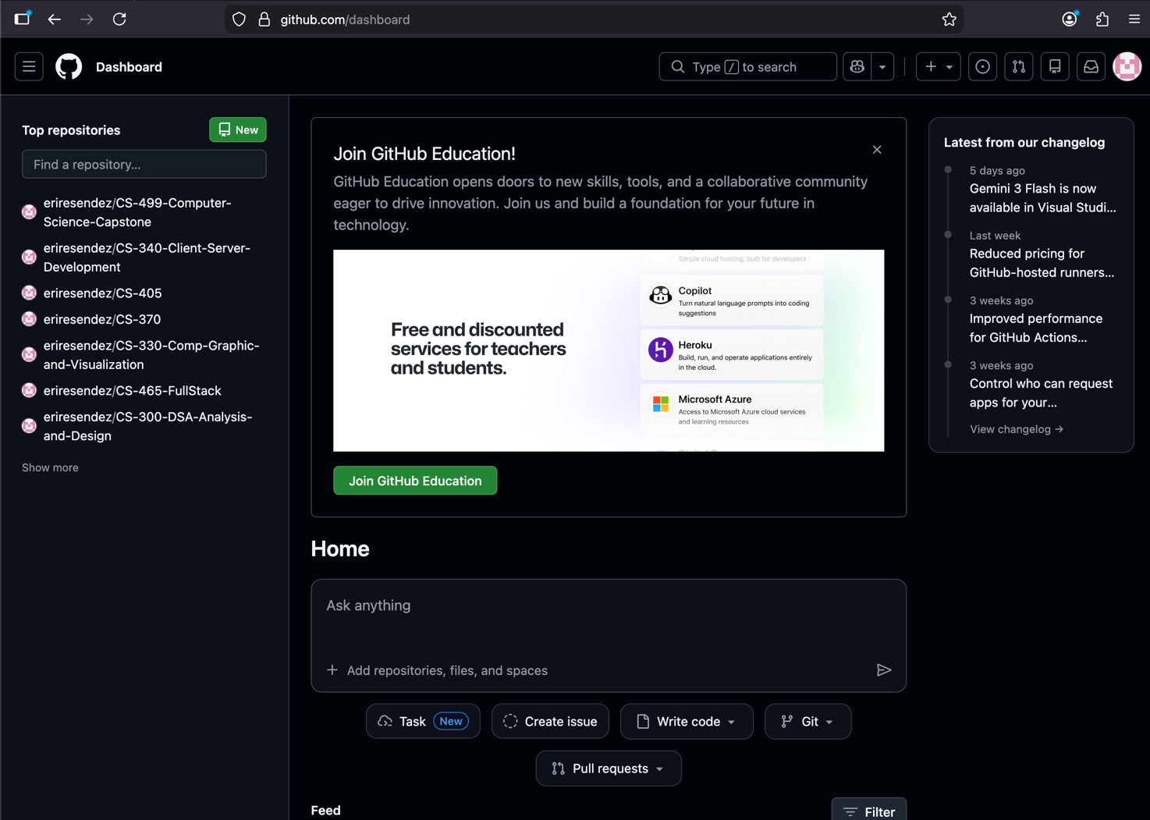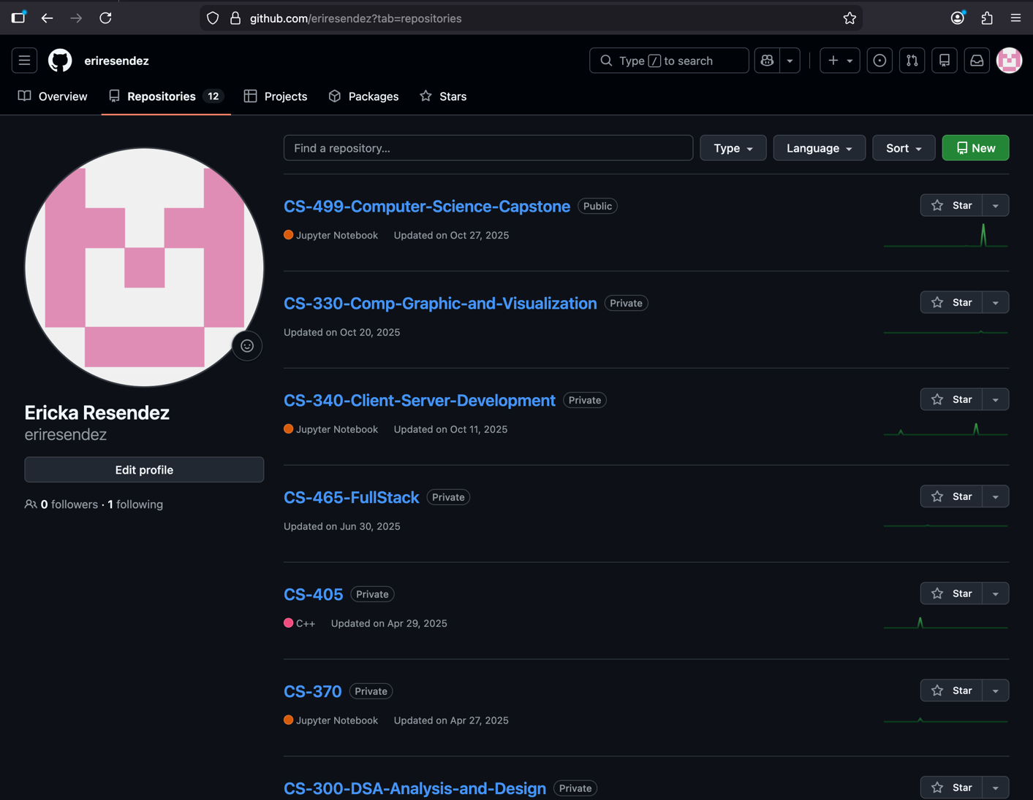

- Enhancement Plan:

• CS 340: Advanced Programming Concepts
• CS 360: Mobile Architecture and Programming - Event Tracking App

  - Category One: Software Engineering and Design
    - Select an artifact that is aligned with the software engineering and design category and explain its origin. Submit a file containing the code for the artifact you choose with your enhancement plan.

Artifact: CS-340 Client/ Server Development: Graziozo Salvare Dashboard and CRUD system

This project is the Animal Shelter Dashboard and was built using Python, MongoDB, and the JupyterDash framework with Dash interface for animal rescue operations. It focuses on filtering and identifying dogs suitable for search and rescue training a MondoDB database. It has interactive charts and maps based on the database. Adjustments have been made from the original CS-340 project as it now includes a way to export the animal data into a CSV, JSON, Excel, and PDF files. It also has been modifies to use CSV files instead of MONGODB for a better compatibility.

    - Describe a practical, well-illustrated plan for enhancement in alignment with the category, including a pseudocode or flowchart that illustrates the planned enhancement.

The Dash implementation creates limitations in UI constraints and no user authentication amongst other issues. The enhancement strategy comprises of transferring the system from Dash to a FastAPI backend with possibly React for the frontend. This migration will separate concerns through a clear REST API layer, implement role-based authentication for different user types (admin, rescue team, viewer), add real-time updates via WebSockets, and create a fully responsive mobile-ready interface. This will improve maintainability, scalability, and accessibility while aligning with the application with modern industry-standard architectures.

START APPLICATION

INITIALIZE Backend Server
Load CSV dataset
Initialize AnimalShelter CRUD service
Expose REST API endpoints:
- GET /animals
- POST /animals
- PUT /animals/{id}
- DELETE /animals/{id}
- GET /export/{format}
Enable role-based authentication
Enable WebSocket for real-time updates

INITIALIZE Frontend Client
Render dashboard UI
Display login screen
Authenticate user role (Admin, Rescue Team, Viewer)

ON User Login
Validate credentials
Assign access permissions based on role
Load dashboard data from API

ON Filter Selection
Send filter criteria to backend
Backend applies query logic to dataset
Return filtered results
Update table, chart, and map views

ON Table Row Selection
Retrieve selected animal data
Update geolocation map marker
Display detailed animal information

ON Export Request
Validate user permissions
Generate requested file format (CSV, JSON, Excel, PDF)
Return export confirmation to user

ON Data Update
Update dataset through CRUD service
Broadcast update via WebSocket
Refresh connected client dashboards

END APPLICATION

For this category of enhancement, consider improving a piece of software, transferring a project into a different language, reverse engineering a piece of software for a different operating system, or expanding a project’s complexity. These are just recommendations. Consider being creative and proposing an alternative enhancement to your instructor.

Think about what additions to include to complete the enhancement criteria in this category. Since one example option is to port to a new language, that is the kind of scale that is expected. This does not mean you need to port to a new language but instead have an equivalent scale of enhancement. Underlying expectations of any enhancement include fixing errors, debugging, and cleaning up comments, but these are not enhancements themselves.

    - Explain how the planned enhancement will demonstrate specific skills and align with course outcomes.

      - Identify and describe the specific skills you will demonstrate that align with the course outcome.

I plan to demonstrate skills that include modern frontend development with React, real-time data synchronization through WebSockets, role-based access control systems.

      - Select one or more of the course outcomes below that your enhancement will align with.

A course outcome the enhancement will align with is outcome number two that states: Design, develop, and deliver professional-quality oral, written, and visual communications that are coherent, technically sound, and appropriately adapted to specific audiences and contexts. This will be demonstrated through the user-friendly interface design for users and comprehensive API documentation.

Another course outcome that the enhancement is expected to align with is outcome number four which states: 4. Demonstrate an ability to use well-founded and innovative techniques, skills, and tools in computing practices for the purpose of implementing computer solutions that deliver value and accomplish industry-specific goals. This will be done by using modern web frameworks like FastAPI and React to deliver operation value to the Austin animal rescue organization.

Course Outcomes:

- Employ strategies for building collaborative environments that enable diverse audiences to support organizational decision-making in the field of computer science.
- Design, develop, and deliver professional-quality oral, written, and visual communications that are coherent, technically sound, and appropriately adapted to specific audiences and contexts.
- Design and evaluate computing solutions that solve a given problem using algorithmic principles and computer science practices and standards appropriate to its solution while managing the trade-offs involved in design choices.
- Demonstrate an ability to use well-founded and innovative techniques, skills, and tools in computing practices for the purpose of implementing computer solutions that deliver value and accomplish industry-specific goals.
- Develop a security mindset that anticipates adversarial exploits in software architecture and designs to expose potential vulnerabilities, mitigate design flaws, and ensure privacy and enhanced security of data and resources.

  - Category Two: Algorithms and Data Structures

- Select an artifact that is aligned with the algorithms and data structures category and explain its origin. Submit a file containing the code for the artifact you choose with your enhancement plan. You may choose work from the courses listed under Category One.

Artifact: CS-360 Android Studio Event Tracking App

This artifact consists of an event management app developed for CS-360 Mobile Architecture and Programming. It is a very simple app that allows users to create, view, and manage events. Users can log in, create an account, and add events with sections like the tile, date and descriptions. It also has a page that has a toggle option to allow or disable SMS notifications. This uses basic ArrayList structures with linear search operations that can lead to issues with a larger dataset.

- Describe a practical, well-illustrated plan for enhancement in alignment with the category, including a pseudocode or flowchart that illustrates the planned enhancement.

To enhance the event tracking app, I will improve how it stores and searches for events to make it faster and more efficient. This will improve search efficiency and data organization by replacing linear search operations with more efficient data structures. I'll replace the exisiting ArrayList event storage with a HashMap so the app can instantly find any event by its ID instead of searching through the whole list. Additionally, I'll use a TreeMap to keep events sorted by date, making it quick to find events within a specific time range. These changes will reduce the time spent searching for an event and improve date range queries.

I would like to incorporate a Trie data structure for pre-fix event name searching and an LRU cache to store frequently accessed events and developing a composite filter system to reduce the time spent searching for an event, improve date range queries, but am unsure if this is manageable. This may be an enhancement for a future occasion.

Pseudocode:
Initialize HashMap<EventID, Event> eventMap
Initialize TreeMap<Date, List<Event>> dateMap

function addEvent(event):
eventMap.put(event.id, event)
dateMap.getOrCreate(event.date).add(event)

function getEventById(eventId):
return eventMap.get(eventId)

function getEventsByDateRange(startDate, endDate):
return dateMap.subMap(startDate, endDate)

For this category of enhancement, consider improving the efficiency of a project or expanding the complexity of the use of data structures and algorithms for your artifact. These are just recommendations. Consider being creative and proposing an alternative enhancement to your instructor. Note: You only need to choose one type of enhancement per category.

Think about what additions to include to complete the enhancement criteria in this category. Since one example option is to port to a new language, that is the kind of scale that is expected. Perhaps you might increase the efficiency and time complexity of an algorithm in an application and detail the logic of the increased time complexity. Remember, you do not need to port to a new language but instead have an equivalent scale of enhancement. Underlying expectations of any enhancement include fixing errors, debugging, and cleaning up comments, but these are not enhancements themselves.

- Explain how the planned enhancement will demonstrate specific skills and align with course outcomes.

  - Identify and describe the specific skills you will demonstrate to align with the course outcome.

Skills I plan to demonstrate are algorithm optimization techniques, use of frameworks like HashMap and TreeMap, performance analysis, and evaluation of algorithmic trade-offs.

  - Select one or more of the course outcomes listed under Category One that your enhancement will align with.

A course outcome I plan to align my enhancement with is outcome number three that states: Design and evaluate computing solutions that solve a given problem using algorithmic principles and computer science practices and standards appropriate to its solution while managing the trade-offs involved in design choices. This outcome is addressed by redesigning the event storage and retrieval logic using appropriate data structures, improving performance while balancing memory usage and maintainability.

  - Category Three: Databases

    - Select an artifact that is aligned with the databases category and explain its origin. Submit a file containing the code for the artifact you choose with your enhancement plan. You may choose work from the courses listed under Category One.

Artifact: CS-360 Android Studio Event Tracking App

This artifact will utilize the event tracking application again. It allows users to create, view, and manage events. The events are able to be stored, retrieved, and displayed to the user. It does make the user log in and has an option to create an account or if the password is forgotten, it begins the process to send a reset password link.

    - Describe a practical, well-illustrated plan for enhancement in alignment with the category, including a pseudocode or flowchart that illustrates the planned enhancement.

The enhancement involves migrating from raw SQLite usage to the Room persistence library and implementing a structured MVVM architecture. This enhancement introduces clearly defined database entities, Data Access Objects (DAOs), and repository patterns to improve data integrity, maintainability, and separation of concerns. Database indexing, versioning, and migration support are incorporated to ensure efficient querying and safe data updates. By adopting Room and MVVM, the application benefits from type-safe queries, reduced runtime errors, and lifecycle-aware data updates, resulting in a more robust and scalable database design.

For this category of enhancement, consider adding more advanced concepts of MySQL, incorporating data mining, creating a MongoDB interface with HTML/JavaScript, or building a full stack with a different programming language for your artifact. These are just recommendations; consider being creative and proposing an alternative enhancement to your instructor. Note: You only need to choose one type of enhancement per category.

Think about what additions to include to complete the enhancement criteria in this category. Since one example option is to port to a new language, that is the kind of scale that is expected. Perhaps you might increase the efficiency and time complexity of an algorithm in an application and detail the logic of the increased time complexity. Remember, you do not need to port to a new language but instead have an equivalent scale of enhancement. Underlying expectations of any enhancement include fixing errors, debugging, and cleaning up comments, but these are not enhancements themselves.
    - Explain how the planned enhancement will demonstrate specific skills and align with course outcomes.

      - Identify and describe the specific skills you will demonstrate that align with the course outcome.

I will demonstrate modern Android architecture implementation with MVVM pattern application, repository pattern design for data abstraction, database schema design with entity relationships and constraints, query optimization with performance considerations, and secure database practices including input validation and transaction management.

      - Select one or more of the course outcomes listed under Category One that your enhancement will align with.

The enhancement will algin with course outcome number five that states: Develop a security mindset that anticipates adversarial exploits in software architecture and designs to expose potential vulnerabilities, mitigate design flaws, and ensure privacy and enhanced security of data and resources. This outcome will be addressed by imprvoing database design through structured schemas, parameterized queries, input validation, and controlled data access, reducing the risk of data corruption and unauthorized manipulation.

- ePortfolio Overall Skill Set

  - Accurately describe the skill set to be illustrated by the ePortfolio overall.
    - Skills and outcomes planned to be illustrated in the code review

The code review will illustrate a strong capacity for technical analysis, including the identification of performance bottlenecks, architectural flaws, and opportunities for optimization across both web and mobile platforms. It will showcase the application of established software engineering principles, such as selecting appropriate design patterns, adhering to coding standards, and ensuring maintainability through clear documentation and structured testing. These skills align with Course Outcome 3, as they demonstrate the ability to evaluate and improve computing solutions using algorithmic principles and sound development practices.

    - Skills and outcomes planned to be illustrated in the narratives

The narratives will illustrate effective technical communication and the ability to tailor explanations for diverse audiences, from rescue team end-users to fellow developers. They will document a systematic problem-solving approach, detailing how limitations were identified in the original artifacts and how enhancements were logically planned and executed. This structured storytelling aligns with Course Outcome 2, as it involves designing and delivering coherent, technically sound communications adapted to specific contexts and stakeholders.

    - Skills and outcomes planned to be illustrated in the professional self-assessment

The professional self-assessment will bring together the technical and communicative aspects of the ePortfolio by reflecting on personal growth, ethical responsibility, and long-term professional development. It will highlight the evolution of skills from foundational implementations to more advanced, integrated solutions while emphasizing the importance of collaboration, user feedback, and iterative improvement. Additionally, the self-assessment will address ethical considerations such as data privacy, security, and accessibility. These reflections align with Course Outcome 5, demonstrating a proactive security mindset and a commitment to responsible software design that protects users and system resources.

Resources:

GeeksforGeeks. (2012, September 28). LRU Cache Complete Tutorial. GeeksforGeeks. https://www.geeksforgeeks.org/system-design/lru-cache-implementation/
JAGTAP, P. (2023, January 21). RestAPI VS FastAPI. Medium; Python in Plain English. https://medium.com/@jagtaprathmesh19/restapi-vs-fastapi-ecee6c2cb2d0
Meta Open Source. (2025). React. React.dev. https://react.dev/
‌

